*'Author : Muhammad Zulhilmi Bin Rosli*

*'No. Matric : S61807*

*'FInal Exam ( CSF3023) 14/2/2022)*

*'Question A*

filePath = ("C:\ZUL\Small Basic\Final")

readFile_ItemData = File.ReadContents(filePath + "\ ITEMDATA.txt")

**For** i=1 **To** File.ReadLine(filePath + "\ITEMDATA.txt",1)

line1 = i

itemdata[i] = File.ReadLine(filePath + "\ITEMDATA.txt",i+1)

TextWindow.WriteLine(ITEMDATA[i]["itemName"])

TextWindow.WriteLine(ITEMDATA[i]["itemCode"])

TextWindow.WriteLine(ITEMDATA[i]["stockQty"])

TextWindow.WriteLine(ITEMDATA[i]["priceUnit"])

**Endfor**

filePath = ("C:\ZUL\Small Basic\Final")

readFile_SalesData = File.ReadContents(filePath + "\SALESDATA.txt")

**For** i=1 **To** File.ReadLine(filePath + "\SALESDATA.txt",1)

line2 = i

salesdata[i] = File.ReadLine(filePath + "\SALESDATA.txt",i+1)

TextWindow.WriteLine(SALESDATA[i]["salesDate"])

TextWindow.WriteLine(SALESDATA[i]["itemCode"])

TextWindow.WriteLine(SALESDATA[i]["salesQty"])

**Endfor**

TextWindow.WriteLine(" Question B (Sorting Item Code)")

TextWindow.WriteLine("")

TextWindow.WriteLine(" | ItemName | ItemCode | StockQty | PriceUnit |")

**For** i=1 **To** line1

TextWindow.WriteLine(" | "+ITEMDATA[i]["itemName"]+" | "+ITEMDATA[i]["itemCode"]+" | "+ITEMDATA[i]["stockQty"]+" | "+ITEMDATA[i]["priceUnit"]+" | ")

**EndFor**

TextWindow.WriteLine("")

TextWindow.WriteLine(" Question C (Sorting Date)")

TextWindow.WriteLine("")

TextWindow.WriteLine(" | SalesDate | ItemCode | SalesQty |")

TextWindow.WriteLine(" |___________|____________|____________|")

**For** x=1 **To** line2

TextWindow.WriteLine(" | "+SALESDATA[x]["salesDate"]+" | "+SALESDATA[x]["itemCode"]+" | "+SALESDATA[x]["salesQty"]+" | ")

**EndFor**

total = 0

d=0

*'FOR DAILY*

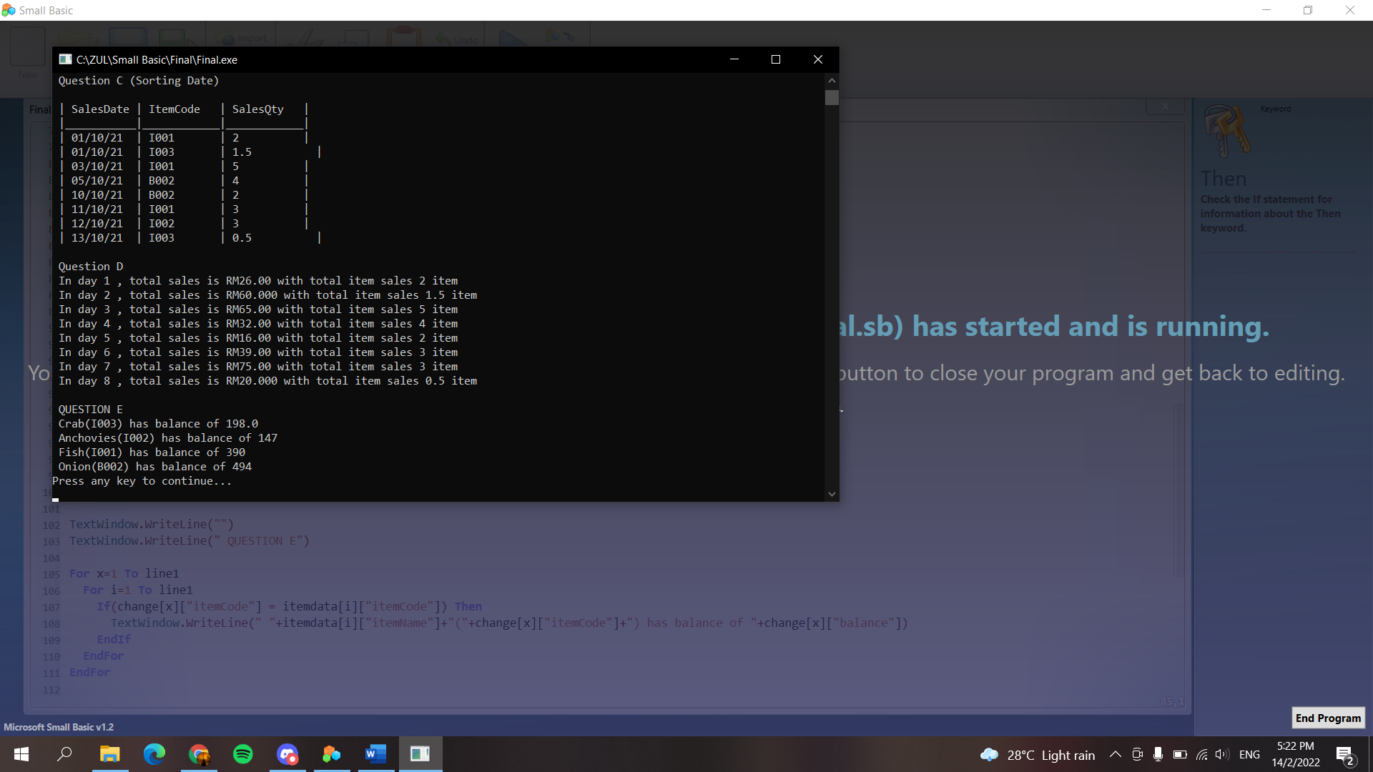

TextWindow.WriteLine("")

TextWindow.WriteLine(" Question D")

**For** j=1 **To** line2

**If**(day[d] <> salesData[j]["day"]) **Then**

d = d+1

**EndIf**

day[d] = salesData[j]["day"]

total[d]["daily"] = total[d]["daily"] + salesData[j]["salesQty"]

**For** i=1 **To** line1

**if** (salesData[j]["itemcode"] = itemData[i]["itemCode"]) **then**

total[d]["priceDaily"] = total[d]["priceDaily"] + ( salesData[j]["salesQty"] * itemdata[i]["priceUnit"] )

**EndIf**

**EndFor**

**EndFor**

**For** x=1 **To** d

TextWindow.WriteLine(" In day "+x+" , total sales is RM"+total[x]["priceDaily"]+" with total item sales "+total[x]["daily"]+" item")

**EndFor**

change = 0

*'BALANCE*

**For** i=1 **To** line1

itemData[i]["temp"] = itemdata[i]["stockQty"]

**EndFor**

**For** j=1 **To** line2

**For** i=1 **To** line1

**If** ( salesData[j]["itemcode"] = itemData[i]["itemCode"] ) **then**

salesData[j]["balance"] = itemData[i]["temp"]

salesData[j]["balance"] = salesData[j]["balance"] - salesData[j]["salesQty"]

itemData[i]["temp"] = salesData[j]["balance"]

**EndIf**

**EndFor**

**EndFor**

*'CURRENT BALANCE*

c=0

change[c]["itemCode"] = 0

**For** j=line2 **To** 1 **Step**-1

**For** g=1 **To** line2

**If**(change[g]["itemCode"] = salesData[j]["itemCode"]) **Then**

**Goto** here

**EndIf**

**EndFor**

c = c+1

change[c]["itemCode"] = salesData[j]["itemCode"]

change[c]["balance"] = salesData[j]["balance"]

change[c]["SalesDate"] = salesData[j]["SalesDate"]

here:

**EndFor**

TextWindow.WriteLine("")

TextWindow.WriteLine(" QUESTION E")



**For** x=1 **To** line1

**For** i=1 **To** line1

**If**(change[x]["itemCode"] = itemdata[i]["itemCode"]) **Then**

TextWindow.WriteLine(" "+itemdata[i]["itemName"]+"("+change[x]["itemCode"]+") has balance of "+change[x]["balance"])

**EndIf**

**EndFor**

**EndFor**

TextWindow.WriteLine("")

TextWindow.WriteLine("Question F ")

TextWindow.Write(" Enter Item Code : ")

Option = TextWindow.Read()

**If** (Option=ITEMDATA[i]["itemCode"]) **Then**

**EndIf**